**Supplementary Data**

**PocketSCP: A Method for Spatiotemporal Topological Visualization and Analysis of Protein Pocket Dynamics**

Dongliang Guo1,*, Hanqing Zhao, Jiabin Huang, Jiawei Zhao, Ximing Xu

1 Department of Information Science and Engineering,Yanshan University

*Correspondence:Dongliang Guo,Tel:+86 13785913004 Email:dongliangguo@ysu.edu.cn

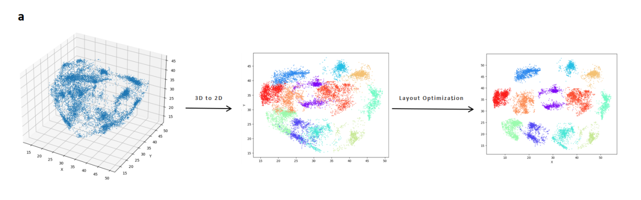

**Figure S1.** Layout optimization : (a) Perform K-means clustering on pocket scatter points in 3D space, and select the positions of the pocket scatter points on the reference conformation as the initial centers for the K-means clustering. After K-means clustering, scatter points belonging to the same cluster have the same label. Once the scatter points are mapped onto a 2D plane, calculate the center point of each cluster and the distances between all cluster centers. Check for overlap between clusters based on the relationship between the cluster center distances and the given distance threshold ‘threshold’. For each pair of overlapping cluster centers, calculate the direction vector between them and move them in opposite directions by a step size ‘step_size’ to increase the distance between them until there is no overlap between all clusters. Update the positions of all points within the clusters based on the adjusted cluster centers.

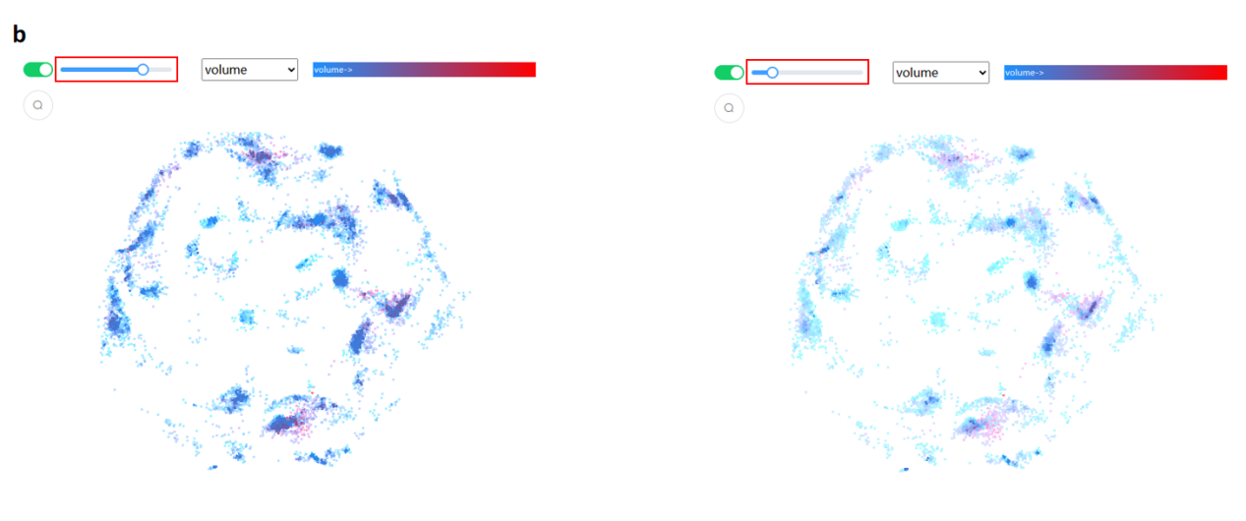

**Figure S2.** Scatter points transparency comparison plot: (b) By adjusting the transparency bar, the more dense the scatter points, the darker the color, and the more sparse the scatter points, the lighter the color. When the bar slides to the left, lower density and higher density areas have more color contrast.

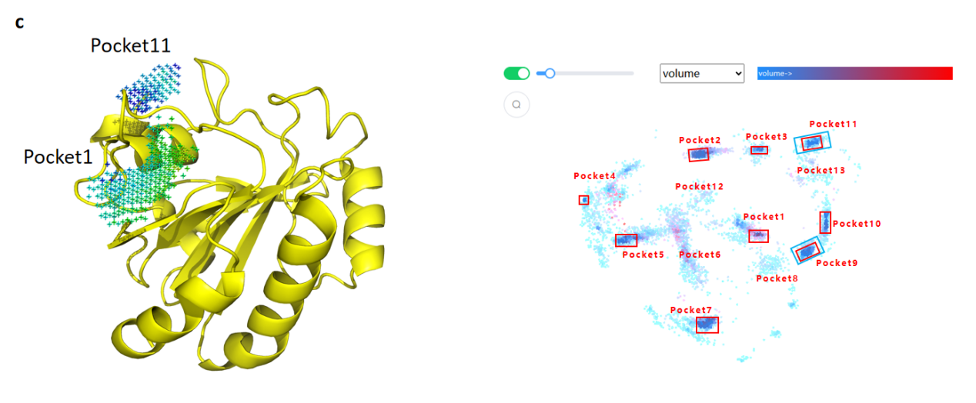

**Figure S3.** Comparison of stability of D3Pockets and PocketSCP : (c) The two pockets on the left are considered by D3Pockets to be the most stable, corresponding to Pocket1 and Pocket11 in the scatter plot. The areas in the red box on the right are the areas where the scattered points are concentrated, and these areas correspond to where the pockets are concentrated most of the time.

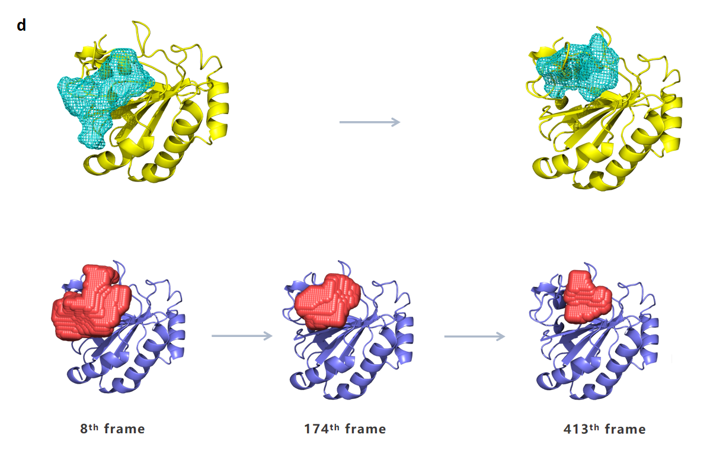

**Figure S4.** Pocket continuity comparison diagram : (d) The top figure is the pocket result returned by D3Pockets. In this area, D3pockets detected a gradual decrease in pocket size. In the following figure, PocketSCP also confirmed the gradual decrease in pocket size in this area through the scatter plot information.

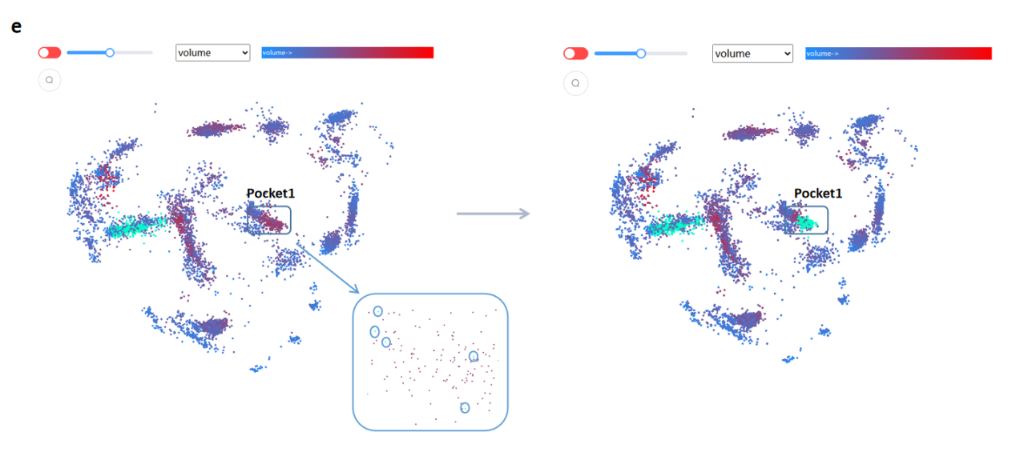

**Figure S5.** Scatter highlight contrast diagram: (e) The five spotlighted scatters in the Pocket1 region on the left are scatters selected based on specific residues, while the spotlighted scatters in the Pocket1 region on the right are scatters in addition to these five scatters with other scatters that do not contain K43 residues.